Experiment No – 6 Date-

DEADLOCK AVOIDANCE

Aim-Implement Algorithm to solve bankers algorithm

Theory –

Deadlock avoidance is one of the three main strategies for handling deadlock in an operating system, alongside prevention and detection/recovery. It is a set of techniques used to ensure the system will never enter an unsafe state—a state from which deadlock is inevitable. Deadlock avoidance requires more information about process resource needs than detection, but is less restrictive than prevention.

Core Concept: Safe State
The entire theory of deadlock avoidance revolves around the concept of a safe state:
- Safe State: A system state is considered safe if there exists a safe sequence of all processes. A safe sequence $\langle P_1, P_2, \dots, P_n \rangle$ is an order in which every process $P_i$ can request its remaining needed resources and then finish. When $P_i$ finishes, it releases its allocated resources, which can then be used by the next process $P_{i+1}$ in the sequence. If the system can always find such a sequence, it can guarantee that no process will be perpetually blocked (deadlocked).
- Unsafe State: A state that is not safe. An unsafe state may lead to a deadlock, but it doesn't guarantee one immediately. However, since the system cannot guarantee that all processes will finish, the avoidance algorithm treats it as a dangerous state to be avoided.
The Avoidance Strategy
The operating system must dynamically check the resource-allocation state to ensure that a circular wait condition can never arise.
- Advance Declaration: Every process must declare the maximum number of resources of each type it may request before it begins execution.
- Resource Request Check: When a process requests a set of resources, the system must determine if granting the request would leave the system in a safe state.
- Conditional Grant:
  - If the resulting state is safe, the resources are allocated to the process.
  - If the resulting state is unsafe, the resources are withheld, and the requesting process must wait until other processes release sufficient resources.

Banker's Algorithm:
The Banker's Algorithm is a deadlock avoidance algorithm proposed by Edsger Dijkstra. Its primary goal is to ensure that a system remains in a safe state—a state where the operating system can guarantee that all processes will eventually complete their execution without entering a deadlock. The algorithm models the operating system as a banker, the processes as customers, and resources as currency (hence the name). A process must state its maximum resource needs upfront. Before granting any resource request, the algorithm simulates the allocation to check if the new state remains safe. If granting the request leads to an unsafe state (where the system cannot find a sequence for all processes to finish), the request is denied, and the process is made to wait. This preemptive check is what makes it an avoidance algorithm, as opposed to detection or prevention methods.

Key Matrice
The Banker's Algorithm relies on four main matrices to track the system's resource status. Let $n$ be the number of processes and $m$ be the number of distinct resource types.
1. Available Vector (or Matrix)
- Size: $1 \times m$
- Purpose: This vector shows the number of instances of each resource type currently available in the system for immediate use.
- Example: If $m=3$ (Resources A, B, C), and Available = $[3, 2, 2]$, it means there are 3 instances of A, 2 instances of B, and 2 instances of C that are unallocated and ready to be granted.
2. Max Matrix
- Size: $n \times m$
- Purpose: This matrix defines the maximum demand of each process for each resource type. This is the largest total amount of resources a process may request throughout its entire execution.
- Example: If Process $P_1$ has Max $[1] = [5, 4, 3]$, it means $P_1$ will never need more than 5 units of A, 4 units of B, and 3 units of C combined (allocated + requested).
3. Allocation Matrix
- Size: $n \times m$
- Purpose: This matrix shows the number of resources of each type currently held (allocated) by each process.
- Example: If Process $P_1$ has Allocation $[1] = [1, 2, 1]$, it means $P_1$ is currently holding 1 unit of A, 2 units of B, and 1 unit of C.
4. Need Matrix
- Size: $n \times m$
- Purpose: This matrix shows the remaining resources each process still needs to complete its task. This is the difference between the Max demand and the Allocation it currently holds. This is the amount the process may request in the future.
{Need}[i, j] = {Max}[i, j] - {Allocation}[i, j]$$
- Example: If a process $P_1$ has:
  - text{Max}[1] = [5, 4, 3]$
  - {Allocation}[1] = [1, 2, 1]$
  - Then, {Need}[1] = [5-1, 4-2, 3-1] = **[4, 2, 2]**$. $P_1$ still needs 4 A, 2 B, and 2 C to complete.
The Safety Algorithm uses the Available and Need matrices to find a safe sequence of processes.

Code –
#include <stdio.h>
#include <stdlib.h>
#include <string.h>
#define BUFFER_SIZE 5
#define ITEM_SIZE 10
char buffer[BUFFER_SIZE][ITEM_SIZE];
int in = 0, out = 0;
int empty = BUFFER_SIZE;
int full = 0;
int mutex = 1;

void wait(int *s) {
if (*s > 0)
(*s)--;
else
printf("Wait failed: semaphore value is zero.\n");
}

void signal(int *s) {
(*s)++;
}

void produce(char item[]) {
wait(&empty);
wait(&mutex);
strcpy(buffer[in], item);
printf("\nAdded: %s at position %d\n", item, in);
in = (in + 1) % BUFFER_SIZE;
signal(&mutex);
signal(&full);
}

void consume() {
wait(&full);
wait(&mutex);
printf("\nRemoved: %s from position %d\n", buffer[out], out);
strcpy(buffer[out], "_");
out = (out + 1) % BUFFER_SIZE;
signal(&mutex);
signal(&empty);
}

void displayBuffer() {
int i;
printf("\nBuffer Status:\n");
printf("--------------\n");
for (i = 0; i < BUFFER_SIZE; i++) {
printf("Slot %d: %s\n", i, buffer[i]);
} printf("--------------\n"); printf("Empty: %d, Full: %d, In: %d, Out: %d\n", empty, full, in, out);
}
int main() {
int choice;
char item[ITEM_SIZE];
for (int i = 0; i < BUFFER_SIZE; i++)
strcpy(buffer[i], "_");

while (1) {
printf("\n--- MENU ---\n");
printf("1. Produce Item\n");
printf("2. Consume Item\n");
printf("3. Display Buffer\n");
printf("4. Exit\n");
printf("Enter choice: ");
scanf("%d", &choice);

switch (choice) {
case 1:
if (empty == 0)
printf("\nOverflow\n");
else {
printf("Enter item: ", ITEM_SIZE - 1);
scanf("%s", item);
produce(item);
}
break;
case 2:
if (full == 0)
printf("\nUnderflow\n");
else
consume();
break;
case 3:
displayBuffer();
break;
case 4:
printf("\nExiting...\n");
exit(0);
default:
printf("\nInvalid choice\n"); }
}
return 0;
}
OUTPUT –
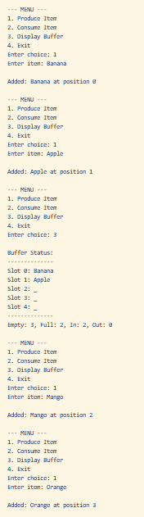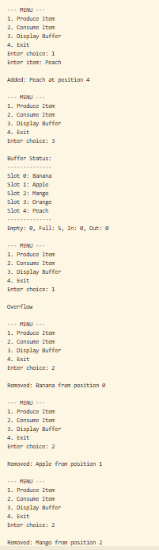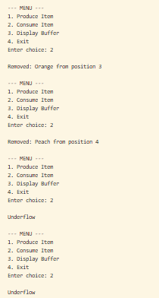

Conclusion – Algorithm to solve producer consumer problem was implemented successfully.

